 | 
Local Insight Summary Report  Central Bedfordshire  Central Bedfordshire Council  20 February 2024 | 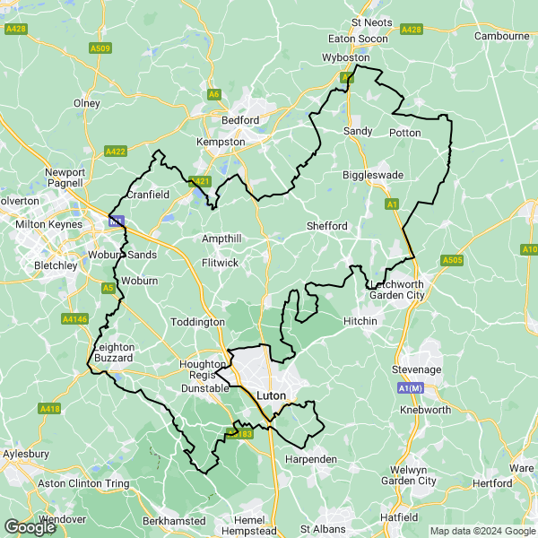

Introduction

Local Insight
Local Insight provides instant access to the information you need for the neighbourhoods you care about.
We bring together small-area social and demographic data in one easy to use and intuitive platform. You can explore data for any area you are interested in through maps, dashboards and reports.
Find out more at: localinsight.org

OCSI
We combine expertise in research and technology to support organisations working for social good to make evidence-based decisions. We have worked with more than 250 public and community sector organisations from local to international level.
Our research and services are based on unrivalled knowledge and use of place-based social, economic and demographic data.
Find out more at: ocsi.uk

About the indicators
OCSI routinely collect all small-area data published by more than 50 government agencies and other reputable bodies. We identify key indicators relevant to local authorities, grantmakers and charities to include within this report and the Local Insight platform.
We manage and maintain all the data and provide comprehensive metadata so that you can be confident you are using the most up-to-date data.

How we have identified the area of Central Bedfordshire
This report is based on the “Central Bedfordshire” area created by Central Bedfordshire Council. There is a map image of the area at the start of this report.
We use sophisticated aggregation and apportioning methods to calculate the data values used in the charts and tables in this report.
Alongside data for the “Central Bedfordshire” area, we also display data for the selected comparator areas: East of England and England.

Contents
Population
Unemployment
Housing
Crime
Health
Education
Employment
Communities and Environment
Access and Transport
Appendix: Data sources

Population
The following data is a summary of key population demographics.
The table below provides an overview of people living in Central Bedfordshire. These population figures provide detail of the structure of the population by broad age bands and by sex. Finally, it also includes a measure of population density by hectare.
The total population of Central Bedfordshire was 294,252 people in 2021.
Of the total population in Central Bedfordshire in 2021, 19.54% are children aged under 16, 62.47% are adults aged 16-64, and 17.99% are over 65 years old.

Population overview
Indicator | Central Bedfordshire |  | East of England |  | England
 | Count | Rate | Count | Rate | Count | Rate
All people (Census 2021) (2021) | 294,252 | - | 6,335,074 | - | 56,490,048 | -
All Females (Census 2021) (2021) | 149,123 | 50.68% | 3,228,097 | 50.96% | 28,833,712 | 51.04%
All Males (Census 2021) (2021) | 145,129 | 49.32% | 3,106,977 | 49.04% | 27,656,336 | 48.96%
Population aged under 16 (Census 2021) (2021) | 57,491 | 19.54% | 1,186,793 | 18.73% | 10,483,091 | 18.56%
Population aged 16 to 64 (Census 2021) (2021) | 183,813 | 62.47% | 3,905,158 | 61.64% | 35,605,654 | 63.03%
Population aged 65+ (Census 2021) (2021) | 52,947 | 17.99% | 1,243,124 | 19.62% | 10,401,303 | 18.41%
Population Density (Persons per sq km) (Census 2021) (2021) | 294,252 | 411.16 | 6,335,074 | 331.23 | 56,490,048 | 433.10
Source: UK Census

Index of Multiple Deprivation (IMD)

The following visualisations draw upon data from the Index of Multiple Deprivation (IMD) to give insight into vulnerable populations in Central Bedfordshire, East of England, England. The Indices of Deprivation 2019 are a relative measure of deprivation for small areas (Lower-layer Super Output Areas) across England. The overall Index of Multiple Deprivation 2019 combines together indicators under seven different domains of deprivation: Income Deprivation; Employment Deprivation; Education Skills and Training Deprivation; Health Deprivation and Disability; Crime; Barriers to Housing and Services and Living Environment Deprivation. A higher score indicates that an area is experiencing high levels of deprivation.
The table below shows the IMD score and rank (average LSOA Rank, where a lower rank indicates that an area is experiencing high levels of deprivation) for Central Bedfordshire, East of England and England.
Central Bedfordshire has an IMD score of 12.15. This means that Central Bedfordshire has lower levels of deprivation to East of England (17.46) and lower levels of deprivation to England (21.76).

Index of Multiple Deprivation (IMD)
Indicator | Central Bedfordshire | East of England | England
Index of Multiple Deprivation 2019 (IMD) Score (2019) | 12.15 | 17.46 | 21.76
Index of Multiple Deprivation (IMD) 2019 Rank (2019) | 23,048 | 18,824 | 16,356
Source: Ministry of Housing Communities and Local Government (MHCLG) 2019

The bar chart below explores this further, showing the proportion of people living in neighbourhoods grouped into deciles according to level of deprivation derived from the IMD. A higher score on the IMD indicates that an area is experiencing greater levels of deprivation. To clarify, all neighbourhoods in England are grouped into ten equal sized groups “deciles”; neighbourhoods in decile 1 fall within the most deprived 10% of neighbourhoods nationally, whilst neighbourhoods in decile 10 fall within the least deprived 10% of neighbourhoods nationally.

Proportion of people in each deprivation decile
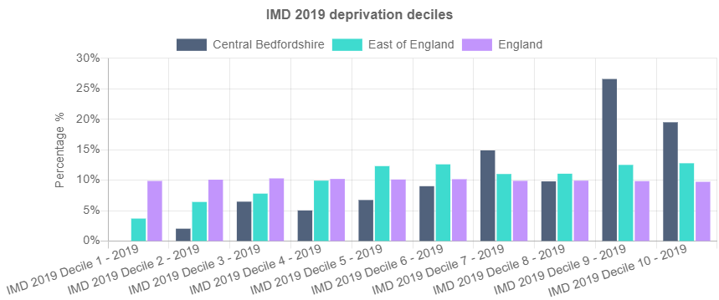
Source: Ministry of Housing Communities and Local Government (MHCLG) 2019

Unemployment
The following data shows the key unemployment indicators.
The table below shows the total number and proportion of people receiving Universal Credit (UC) or Job Seekers Allowance (JSA) by age and sex. The proportion of working age people receiving benefits for unemployment in Central Bedfordshire was 2.30% in Jan-2024. This is lower than the average across East of England (3.16%) and lower than the average across England (3.92%).

Unemployment Benefit Claimants
Indicator | Central Bedfordshire |  | East of England |  | England
 | Count | Rate | Count | Rate | Count | Rate
Unemployment benefit claimants (Jobseekers Allowance and out of work Universal Credit claimants) (Jan-2024) | 4,210 | 2.30% | 119,950 | 3.16% | 1,367,420 | 3.92%
Youth unemployment (18-24 receiving JSA or Universal Credit) (Jan-2024) | 675 | 3.55% | 20,665 | 4.48% | 240,330 | 5.14%
Older person unemployment (50+ receiving JSA or Universal Credit) (Jan-2024) | 980 | 0.88% | 27,695 | 1.12% | 308,180 | 1.46%
Unemployment benefit (JSA and Universal Credit), female (Jan-2024) | 1,990 | 2.15% | 54,500 | 2.85% | 596,285 | 3.42%
Unemployment benefit (JSA and Universal Credit), male (Jan-2024) | 2,220 | 2.46% | 65,450 | 3.46% | 771,130 | 4.42%
Source: Department for Work and Pensions (DWP)

The chart below shows the total proportion of people receiving unemployment benefit (JSA or Universal Credit) between Jan-2020 and Jan-2024.
The total unemployment rate in Central Bedfordshire has increased from 1.40% in Jan-2020 to 2.30% in Jan-2024.

Unemployment Benefit Claimants (time series)
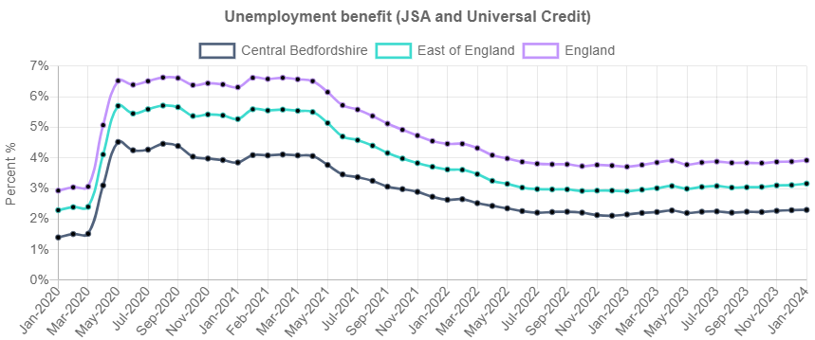
Source: Department for Work and Pensions (DWP)

Housing
The following data is a summary of key housing related indicators.
The table below shows the mean house prices by accommodation type across Central Bedfordshire and the comparator areas for four key dwelling types (flats, semi-detached houses, terraced houses and detached houses) from Dec-2022 to Nov-2023.
The average property price for all dwelling types in Central Bedfordshire is £383,364, this is lower than the average across East of England (£388,120) and higher than the average across England (£358,912).
<i>Data on house prices is from the Land Registry open data price-paid dataset Please note some small areas may not have had a transaction recorded within the twelve month period leading to gaps in the table below.</i>

Average house prices
Indicator | Central Bedfordshire | East of England | England
Average house price (12 months) (Dec-2022 to Nov-2023) | £383,364 | £388,120 | £358,912
Average house price for detached houses (12 months) (Dec-2022 to Nov-2023) | £580,755 | £567,430 | £548,470
Average house price for flats (12 months) (Dec-2022 to Nov-2023) | £184,330 | £218,410 | £307,618
Average house price for semi-detached houses (12 months) (Dec-2022 to Nov-2023) | £373,536 | £379,533 | £324,603
Average house price for terraced houses (12 months) (Dec-2022 to Nov-2023) | £308,581 | £319,408 | £291,130
Source: UK Land Registry

The chart below shows the tenure of housing in Central Bedfordshire, East of England, and England.
Tenure types include;
- ‘Owner occupied’ housing includes accommodation that is either owned outright, owned with a mortgage or loan, or shared ownership (paying part rent and part mortgage).
- ‘Social rented’ housing includes accommodation that is rented from a council (Local Authority) or a Housing Association, Housing Co-operative, Charitable Trust, Non-profit housing company or Registered Social Landlord.
- ‘Rented from the Council includes accommodation rented from the Local Authority.
- ‘Housing Association or Social Landlord’ includes rented from Registered Social Landlord, Housing Association, Housing Co-operative, Charitable Trust and non-profit housing Company.
- ‘Private rented or letting agency’ includes accommodation that is rented from a private landlord or letting agency.
- ‘Other Rented’ includes employer of a household member and relative or friend of a household member and living rent free.<p></p>
In Central Bedfordshire 72.90% of households are owner-occupied, which is higher than the proportion of households in East of England (66.22%), and a higher proportion than England (62.32%).
Overall, 4.65% of households in Central Bedfordshire are rented from the local authority, 8.66% are rented from a housing association and 11.87% are privately rented.

Housing tenure
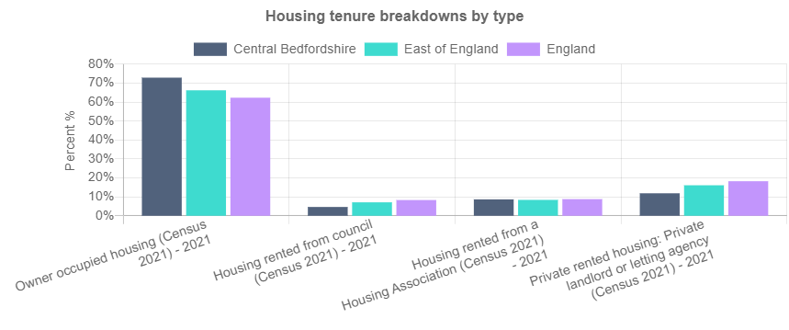
Source: UK Census

Crime
The information below shows the level of recorded crime in Central Bedfordshire and comparator areas. This is based on data for individual crime incidents published via the Police UK open data portal, which has been linked by Local Insight to selected neighbourhoods.
The table below shows counts and rates for the main crime types and anti-social behaviour incidents between Dec-2022 to Nov-2023.
There were 26,814 total crime offences in Central Bedfordshire between Dec-2022 to Nov-2023, with the overall crime rate being 91.2 per 1,000 population. This is lower than the average across East of England (120.3) and lower than the average across England (137.3).

Crime and Anti-Social Behaviour Incidents
Indicator | Central Bedfordshire |  | East of England |  | England
 | Count | Rate | Count | Rate | Count | Rate
Total crime offences (12 month total) (Dec-2022 to Nov-2023) | 26,814 | 91.2 | 754,034 | 120.3 | 7,690,836 | 137.3
Anti-social behaviour (12 month total) (Dec-2022 to Nov-2023) | 5,324 | 18.1 | 106,121 | 16.9 | 1,111,848 | 19.9
Bicycle theft offences (12 month total) (Dec-2022 to Nov-2023) | 221 | 0.8 | 9,110 | 1.5 | 78,331 | 1.4
Burglary (12 month total) (Dec-2022 to Nov-2023) | 1,253 | 10.4 | 29,851 | 11.4 | 343,763 | 14.7
Criminal damage (12 month total) (Dec-2022 to Nov-2023) | 1,958 | 6.7 | 61,418 | 9.8 | 603,633 | 10.8
Drug crime offences (12 month total) (Dec-2022 to Nov-2023) | 502 | 1.7 | 19,921 | 3.2 | 206,407 | 3.7
Other crime offences (12 month total) (Dec-2022 to Nov-2023) | 527 | 1.8 | 15,406 | 2.5 | 140,347 | 2.5
Other theft offences (12 month total) (Dec-2022 to Nov-2023) | 2,338 | 7.9 | 58,321 | 9.3 | 622,560 | 11.1
Shoplifting offences (12 month total) (Dec-2022 to Nov-2023) | 1,425 | 4.8 | 48,896 | 7.8 | 488,895 | 8.7
Possession of weapons offences (12 month total) (Dec-2022 to Nov-2023) | 196 | 0.7 | 7,539 | 1.2 | 67,563 | 1.2
Public order offences (12 month total) (Dec-2022 to Nov-2023) | 1,892 | 6.4 | 55,543 | 8.9 | 599,929 | 10.7
Robbery recorded offences (12 month total) (Dec-2022 to Nov-2023) | 164 | 0.6 | 5,601 | 0.9 | 98,841 | 1.8
Theft from the person offences (12 month total) (Dec-2022 to Nov-2023) | 142 | 0.5 | 5,979 | 1.0 | 151,550 | 2.7
Vehicle crime (12 month total) (Dec-2022 to Nov-2023) | 2,448 | 8.3 | 51,800 | 8.3 | 509,743 | 9.1
Violent crime and sexual offences (12 month total) (Dec-2022 to Nov-2023) | 8,424 | 28.6 | 278,528 | 44.4 | 2,667,426 | 47.6
Source: Police UK (Police recorded crime figures)

The line chart below shows a time series made up of 12 month totals of neighbourhood-level incidents of criminal offences. The figure is a rate per 1,000 residents. The first data point covers Sep-2018 to Aug-2019 and the final data point covers Dec-2022 to Nov-2023.
The overall crime rate in Central Bedfordshire has increased from 81.3 per 1,000 people between Sep-2018 to Aug-2019 to 91.2 per 1,000 people between Dec-2022 to Nov-2023.
<i>Please note there can be missing data in Police.uk crime counts for certain areas. This is often due to issues with IT system changes at various police forces such as Devon and Cornwall, and Greater Manchester currently, which affects their reporting of figures to Police UK. Please see the Police UK change log for details of current known issues.</i>

12 month total crime rate (time series)
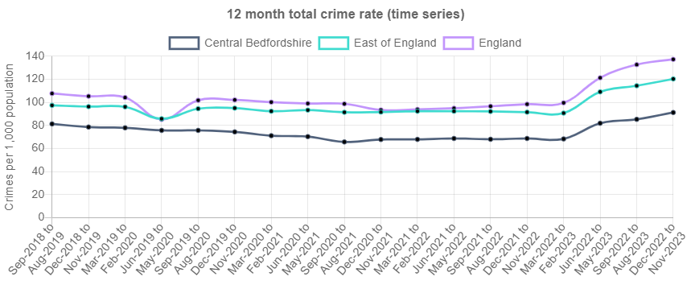
Source: Police UK

Health
The following data provides an overview of people's health with the first table below providing some key health statistics.
There are 16,202 people in Central Bedfordshire who are disabled under the equality act and whose day to day activities are limited a lot. This is 5.51% of the working population, which is lower than East of England (6.64%) and lower than England (7.33%).
In regards to the provision of unpaid care, there are 6,492 people in Central Bedfordshire providing 50+ hours of unpaid care a week. This is 2.35% of the working population, which is lower than East of England (2.50%) and lower than England (2.63%)

Key health statistics
Indicator | Central Bedfordshire |  | East of England |  | England
 | Count | Rate | Count | Rate | Count | Rate
Disabled under the Equality Act: Day-to-day activities limited a lot (Census 2021) (2021) | 16,202 | 5.51% | 420,499 | 6.64% | 4,140,357 | 7.33%
Disabled under the Equality Act: Day-to-day activities limited a little (Census 2021) (2021) | 27,830 | 9.46% | 633,333 | 10.00% | 5,634,153 | 9.97%
Not disabled under the Equality Act: Has long term physical or mental health condition but day-to-day activities are not limited (Census 2021) (2021) | 22,637 | 7.69% | 457,748 | 7.23% | 3,856,029 | 6.83%
Not disabled under the Equality Act: No long term physical or mental health conditions (Census 2021) (2021) | 227,583 | 77.34% | 4,823,493 | 76.14% | 42,859,509 | 75.87%
Very good health (Census 2021) (2021) | 148,210 | 50.37% | 3,058,673 | 48.28% | 27,390,829 | 48.49%
Good health (Census 2021) (2021) | 101,486 | 34.49% | 2,194,562 | 34.64% | 19,040,735 | 33.71%
Very bad health (Census 2021) (2021) | 2,407 | 0.82% | 63,479 | 1.00% | 662,881 | 1.17%
Bad health (Census 2021) (2021) | 8,817 | 3.00% | 226,719 | 3.58% | 2,248,255 | 3.98%
Provides no unpaid care (Census 2021) (2021) | 252,896 | 91.48% | 5,471,915 | 91.41% | 48,734,833 | 91.24%
Provides 50+ hours unpaid care a week (Census 2021) (2021) | 6,492 | 2.35% | 149,937 | 2.50% | 1,404,771 | 2.63%
Children providing unpaid care (Census 2021) (2021) | 522 | 0.91% | 9,540 | 0.80% | 78,810 | 0.75%
Source: UK Census

The chart below shows the most recent number of Personal Independent Payment claimants.
A lower proportion of people in Central Bedfordshire are claiming Personal Independence Payment (5.58%) than in East of England (7.22%) and a lower proportion than in England (8.40%).

Personal Independence Payment (PIP) Claimants
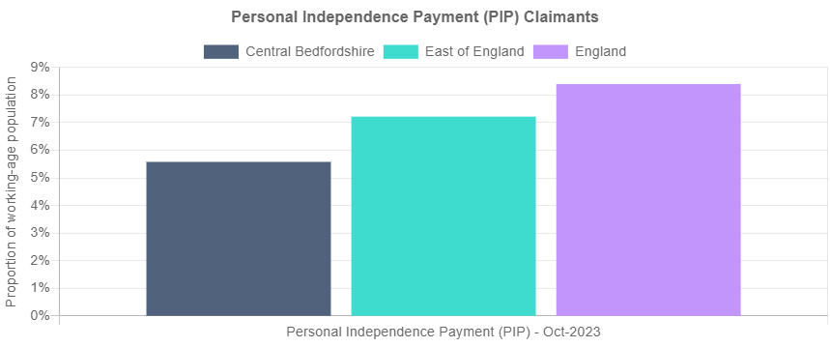
Source: Department for Work and Pensions (DWP)

Education
The following data is a summary of the key indicators related to education.
The table below shows the distribution of qualification levels and the subsequent bar chart shows a comparison of those with no qualifications besides those with degree level qualifications or higher.
There are 35,598 people in Central Bedfordshire with no qualifications, which is 15.04% of all people aged over 16. This is lower than the average for East of England (18.11%) and lower than the average in England (18.08%).
There are 78,654 people with degree level qualifications in Central Bedfordshire, which is 33.22% of people aged 16+. This is higher than the average in East of England (31.57%) and lower than the average in England (33.92%).

Level of qualification
Indicator | Central Bedfordshire |  | East of England |  | England
 | Count | Rate | Count | Rate | Count | Rate
People with no qualifications (Census 2021) (2021) | 35,598 | 15.04% | 932,209 | 18.11% | 8,317,789 | 18.08%
Highest level of qualification: Apprenticeship (Census 2021) (2021) | 14,069 | 5.94% | 284,157 | 5.52% | 2,446,935 | 5.32%
Highest level of qualification: Other qualifications (Census 2021) (2021) | 5,789 | 2.45% | 145,790 | 2.83% | 1,268,468 | 2.76%
Highest level of qualification: Level 1 qualifications (Census 2021) (2021) | 24,650 | 10.41% | 554,976 | 10.78% | 4,456,198 | 9.69%
Highest level of qualification: Level 2 qualifications (Census 2021) (2021) | 34,892 | 14.74% | 742,611 | 14.42% | 6,126,130 | 13.32%
Highest level of qualification: Level 3 qualifications (Census 2021) (2021) | 43,107 | 18.21% | 863,162 | 16.77% | 7,784,977 | 16.92%
Highest level of qualification: Level 4/5 (degree or higher) qualifications (Census 2021) (2021) | 78,654 | 33.22% | 1,625,376 | 31.57% | 15,606,458 | 33.92%
Source: UK Census

No qualifications or degree level and above
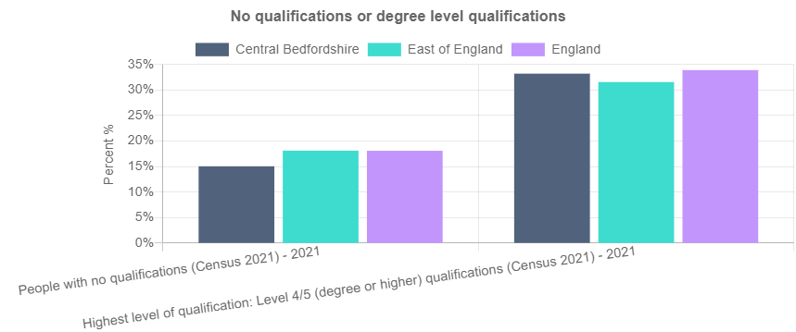
Source: UK Census

Employment
The following data is a summary of key indicators related to employment.
The table below shows figures for the number of people that hold either full or part-time roles alongside the figures for those working in either the public or private sectors.
A higher proportion of people in Central Bedfordshire work in the private sector (85.1%) than the public sector (11.39%). People are less likely to be part-time employed in Central Bedfordshire (30.5%) than in East of England (33.3%) and equally likely than in England (30.8%).

Jobs by type
Indicator | Central Bedfordshire |  | East of England |  | England
 | Count | Rate | Count | Rate | Count | Rate
Full-time employee jobs (2020) | - | - | - | - | - | -
Part-time employee jobs (2020) | 32,000 | 30.5% | 957,000 | 33.3% | 8,225,000 | 30.8%
Public sector employee jobs (2020) | 12,039 | 11.39% | 434,446 | 18.97% | 4,346,035 | 16.01%
Private sector employee jobs (2020) | 89,401 | 85.1% | 2,354,466 | 81.9% | 21,459,353 | 80.5%
Source: Business Register and Employment Survey (BRES)

The jobs density (calculated as the number of jobs per 100 working-age people) in Central Bedfordshire was 57.86% in 2022. This is lower than the average across East of England (60.29%) and lower than the average across England (77.79%).

Jobs density
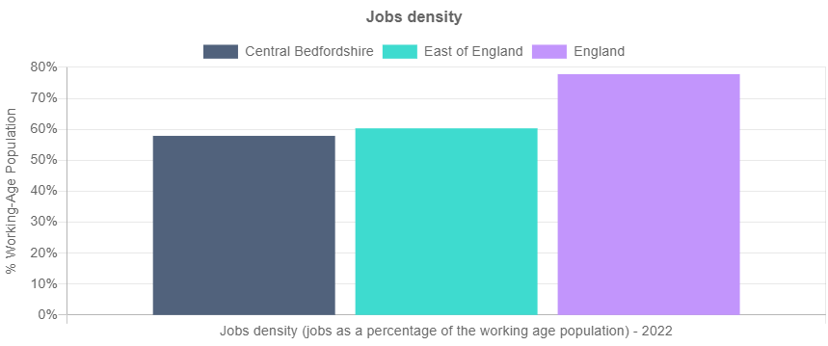
Source: Business Register and Employment Survey (BRES)

Communities and Environment
The following data is a summary of key indicators related to the community and environment.
The first chart below shows the Community Needs Index score. The Community Needs Index was developed to identify areas experiencing poor community and civic infrastructure, relative isolation and low levels of participation in community life. A higher score on this measure indicates that an area has higher levels of community need.
Central Bedfordshire has higher levels of overall need on the Community Needs Index (an overall CNI score of 73.33) than East of England (71.74) and higher levels of need than England (65.55).

CNI domain scores
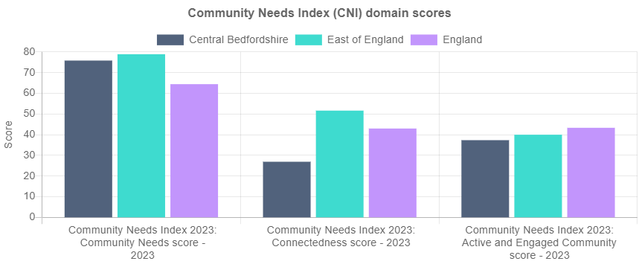
Source: Oxford Consultants for Social Inclusion (OCSI)

Civic Assets score (CNI)
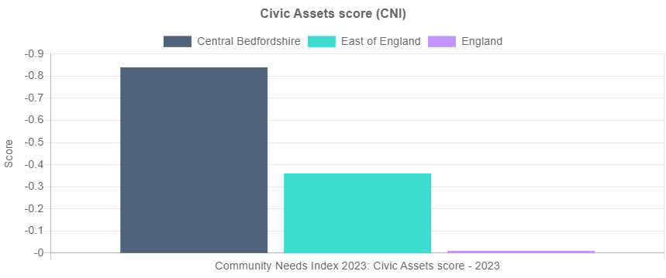
Source: Oxford Consultants for Social Inclusion (OCSI)

The table below shows the Indices of Deprivation Air Quality Measures. For each pollutant the atmospheric concentration was compared to a national standard value, with the concentrations in each Lower-layer Super Output Area divided by the appropriate national standard, before summing to produce a single indicator. A higher score indicates that an area is experiencing relatively higher levels of deprivation.
Based on the IoD 2019 Air quality indicator - Central Bedfordshire has lower levels of air pollution (0.848 IoD score) than East of England (0.875 IoD score) and lower levels of air pollution than England (0.957 IoD score).

Indices of Deprivation Air Quality Measures
Indicator | Central Bedfordshire | East of England | England
IoD 2019 Air quality indicator (2016) | 0.848 | 0.875 | 0.957
IoD 2019 Benzene (component of air quality indicator) (2016) | 0.077 | 0.080 | 0.098
IoD 2019 Nitrogen dioxide (component of air quality indicator) (2016) | 0.341 | 0.361 | 0.430
IoD 2019 Particulates (component of air quality indicator) (2016) | 0.404 | 0.407 | 0.395
IoD 2019 Sulphur dioxide (component of air quality indicator) (2016) | 0.026 | 0.027 | 0.034
IoD 2019 Road traffic accidents indicator (2015 to 2016) | 0.749 | 0.632 | 0.739
Source: Ministry of Housing Communities and Local Government (MHCLG)

Access and Transport
The following data is a summary of the main access and transport related indicators.
The table below shows the proportion of households according to their ownership of a car or van. This is based on responses to the car ownership question in the 2021 Census which asks information on the number of cars or vans owned, or are available for use, by one or more members of a household. This includes company cars and vans available for private use and is based on details for private households only. Cars or vans used by residents of communal establishments are not counted.
In Central Bedfordshire, 11.27% of households have no access to a car or van. This is less than the proportion without access to a car or van in East of England (16.82%) and less than the proportion without access to a car or van in England (23.54%).

Car or van ownership
Indicator | Central Bedfordshire | East of England | England
Households with no car (Census 2021) (2021) | 11.27% | 16.82% | 23.54%
1 car or van in household (Census 2021) (2021) | 38.61% | 41.56% | 41.28%
2 cars or vans in household (Census 2021) (2021) | 36.37% | 30.04% | 26.06%
Households with 3+ cars (Census 2021) (2021) | 13.75% | 11.58% | 9.12%
Source: UK Census

The bar chart below shows the proportion of households with no car or van in the 2021 Census alongside the proportions from previous Censuses to identify changes over time.
In 2011, 13.24% of households in Central Bedfordshire had no access to a car or van. This is greater than the proportion without access to a car or van in 2021 (11.27%).

Households with no car or van
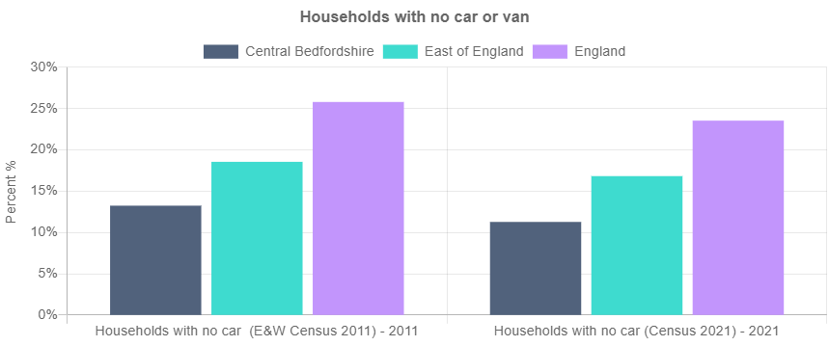
Source: UK Census

Appendix: Data sources

Theme | Data | Data source / time period
Population sample | All people (Census 2021) | Census 2021 (2021)
Population sample | All Females (Census 2021) | Census 2021 (2021)
Population sample | All Males (Census 2021) | Census 2021 (2021)
Population sample | Population aged under 16 (Census 2021) | Census 2021 (2021)
Population sample | Population aged 16 to 64 (Census 2021) | Census 2021 (2021)
Population sample | Population aged 65+ (Census 2021) | Census 2021 (2021)
Population sample | Population Density (Persons per sq km) (Census 2021) | Census 2021 (2021)
Population sample | Index of Multiple Deprivation 2019 (IMD) Score | Ministry of Housing Communities and Local Government (MHCLG) (2019)
Population sample | Index of Multiple Deprivation (IMD) 2019 Rank | Ministry of Housing Communities and Local Government (MHCLG) (2019)
Population sample | IMD 2019 Decile 1 | Communities and Local Government (CLG) (2019)
Population sample | IMD 2019 Decile 2 | Communities and Local Government (CLG) (2019)
Population sample | IMD 2019 Decile 3 | Communities and Local Government (CLG) (2019)
Population sample | IMD 2019 Decile 4 | Communities and Local Government (CLG) (2019)
Population sample | IMD 2019 Decile 5 | Communities and Local Government (CLG) (2019)
Population sample | IMD 2019 Decile 6 | Communities and Local Government (CLG) (2019)
Population sample | IMD 2019 Decile 7 | Communities and Local Government (CLG) (2019)
Population sample | IMD 2019 Decile 8 | Communities and Local Government (CLG) (2019)
Population sample | IMD 2019 Decile 9 | Communities and Local Government (CLG) (2019)
Population sample | IMD 2019 Decile 10 | Communities and Local Government (CLG) (2019)
Unemployment sample | Unemployment benefit claimants (Jobseekers Allowance and out of work Universal Credit claimants) | Department for Work and Pensions (DWP) (Jan-2024)
Unemployment sample | Youth unemployment (18-24 receiving JSA or Universal Credit) | Department for Work and Pensions (DWP) (Jan-2024)
Unemployment sample | Older person unemployment (50+ receiving JSA or Universal Credit) | Department for Work and Pensions (DWP) (Jan-2024)
Unemployment sample | Unemployment benefit (JSA and Universal Credit), female | Department for Work and Pensions (DWP) (Jan-2024)
Unemployment sample | Unemployment benefit (JSA and Universal Credit), male | Department for Work and Pensions (DWP) (Jan-2024)
Unemployment sample | Unemployment benefit claimants (Jobseekers Allowance and out of work Universal Credit claimants) | Department for Work and Pensions (DWP) (Jan-2020)
Housing sample | Average house price (12 months) | Land Registry (Dec-2022 to Nov-2023)
Housing sample | Average house price for detached houses (12 months) | Land Registry (Dec-2022 to Nov-2023)
Housing sample | Average house price for flats (12 months) | Land Registry (Dec-2022 to Nov-2023)
Housing sample | Average house price for semi-detached houses (12 months) | Land Registry (Dec-2022 to Nov-2023)
Housing sample | Average house price for terraced houses (12 months) | Land Registry (Dec-2022 to Nov-2023)
Housing sample | Owner occupied housing (Census 2021) | Census 2021 (2021)
Housing sample | Housing rented from council (Census 2021) | Census 2021 (2021)
Housing sample | Housing rented from a Housing Association (Census 2021) | Census 2021 (2021)
Housing sample | Private rented housing: Private landlord or letting agency (Census 2021) | Census 2021 (2021)
Crime sample | Total crime offences (12 month total) | Police UK (Dec-2022 to Nov-2023)
Crime sample | Anti-social behaviour (12 month total) | Police UK (Dec-2022 to Nov-2023)
Crime sample | Bicycle theft offences (12 month total) | Police UK (Dec-2022 to Nov-2023)
Crime sample | Burglary (12 month total) | Police UK (Dec-2022 to Nov-2023)
Crime sample | Criminal damage (12 month total) | Police UK (Dec-2022 to Nov-2023)
Crime sample | Drug crime offences (12 month total) | Police UK (Dec-2022 to Nov-2023)
Crime sample | Other crime offences (12 month total) | Police UK (Dec-2022 to Nov-2023)
Crime sample | Other theft offences (12 month total) | Police UK (Dec-2022 to Nov-2023)
Crime sample | Shoplifting offences (12 month total) | Police UK (Dec-2022 to Nov-2023)
Crime sample | Possession of weapons offences (12 month total) | Police UK (Dec-2022 to Nov-2023)
Crime sample | Public order offences (12 month total) | Police UK (Dec-2022 to Nov-2023)
Crime sample | Robbery recorded offences (12 month total) | Police UK (Dec-2022 to Nov-2023)
Crime sample | Theft from the person offences (12 month total) | Police UK (Dec-2022 to Nov-2023)
Crime sample | Vehicle crime (12 month total) | Police UK (Dec-2022 to Nov-2023)
Crime sample | Violent crime and sexual offences (12 month total) | Police UK (Dec-2022 to Nov-2023)
Crime sample | Total crime offences (12 month total) | Police UK (Sep-2018 to Aug-2019)
Health sample | Disabled under the Equality Act: Day-to-day activities limited a lot (Census 2021) | Census 2021 (2021)
Health sample | Disabled under the Equality Act: Day-to-day activities limited a little (Census 2021) | Census 2021 (2021)
Health sample | Not disabled under the Equality Act: Has long term physical or mental health condition but day-to-day activities are not limited (Census 2021) | Census 2021 (2021)
Health sample | Not disabled under the Equality Act: No long term physical or mental health conditions (Census 2021) | Census 2021 (2021)
Health sample | Very good health (Census 2021) | Census 2021 (2021)
Health sample | Good health (Census 2021) | Census 2021 (2021)
Health sample | Very bad health (Census 2021) | Census 2021 (2021)
Health sample | Bad health (Census 2021) | Census 2021 (2021)
Health sample | Provides no unpaid care (Census 2021) | Census 2021 (2021)
Health sample | Provides 50+ hours unpaid care a week (Census 2021) | Census 2021 (2021)
Health sample | Children providing unpaid care (Census 2021) | Census 2021 (2021)
Health sample | Personal Independence Payment (PIP) | Department for Work and Pensions (DWP) (Oct-2023)
Education sample | People with no qualifications (Census 2021) | Census 2021 (2021)
Education sample | Highest level of qualification: Apprenticeship (Census 2021) | Census 2021 (2021)
Education sample | Highest level of qualification: Other qualifications (Census 2021) | Census 2021 (2021)
Education sample | Highest level of qualification: Level 1 qualifications (Census 2021) | Census 2021 (2021)
Education sample | Highest level of qualification: Level 2 qualifications (Census 2021) | Census 2021 (2021)
Education sample | Highest level of qualification: Level 3 qualifications (Census 2021) | Census 2021 (2021)
Education sample | Highest level of qualification: Level 4/5 (degree or higher) qualifications (Census 2021) | Census 2021 (2021)
Education sample | People with no qualifications (Census 2021) | Census 2021 (2021)
Education sample | Highest level of qualification: Level 4/5 (degree or higher) qualifications (Census 2021) | Census 2021 (2021)
Employment sample | Full-time employee jobs | Business Register and Employment Survey (BRES) (2020)
Employment sample | Part-time employee jobs | Business Register and Employment Survey (BRES) (link) (2020)
Employment sample | Public sector employee jobs | Business Register and Employment Survey (BRES) (2020)
Employment sample | Private sector employee jobs | Business Register and Employment Survey (BRES) (link) (2020)
Employment sample | Jobs density (jobs as a percentage of the working age population) | Business Register and Employment Survey (BRES) (2022)
Communities and Environment sample | Community Needs Index 2023: Community Needs score | Oxford Consultants for Social Inclusion (OCSI) and Local Trust (2023)
Communities and Environment sample | Community Needs Index 2023: Connectedness score | Oxford Consultants for Social Inclusion (OCSI) and Local Trust (2023)
Communities and Environment sample | Community Needs Index 2023: Active and Engaged Community score | Oxford Consultants for Social Inclusion (OCSI) and Local Trust (2023)
Communities and Environment sample | Community Needs Index 2023: Civic Assets score | Oxford Consultants for Social Inclusion (OCSI) and Local Trust (2023)
Communities and Environment sample | IoD 2019 Air quality indicator | Ministry of Housing Communities and Local Government (MHCLG) (2016)
Communities and Environment sample | IoD 2019 Benzene (component of air quality indicator) | Ministry of Housing Communities and Local Government (MHCLG) (2016)
Communities and Environment sample | IoD 2019 Nitrogen dioxide (component of air quality indicator) | Ministry of Housing Communities and Local Government (MHCLG) (2016)
Communities and Environment sample | IoD 2019 Particulates (component of air quality indicator) | Ministry of Housing Communities and Local Government (MHCLG) (2016)
Communities and Environment sample | IoD 2019 Sulphur dioxide (component of air quality indicator) | Ministry of Housing Communities and Local Government (MHCLG) (2016)
Communities and Environment sample | IoD 2019 Road traffic accidents indicator | Ministry of Housing Communities and Local Government (MHCLG) (2015 to 2016)
Access and Transport sample | Households with no car (Census 2021) | Census 2021 (2021)
Access and Transport sample | 1 car or van in household (Census 2021) | Census 2021 (2021)
Access and Transport sample | 2 cars or vans in household (Census 2021) | Census 2021 (2021)
Access and Transport sample | Households with 3+ cars (Census 2021) | Census 2021 (2021)
Access and Transport sample | Households with no car (E&W Census 2011) | Census 2011 (2011)
Access and Transport sample | Households with no car (Census 2021) | Census 2021 (2021)

