
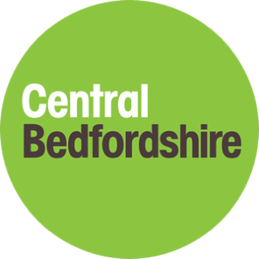

Pharmacy services in Central Bedfordshire

Easy Read

Easy Read


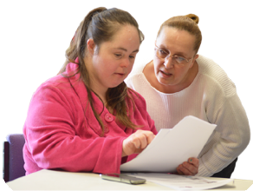
This is an Easy Read version of some information. It may not include all of the information but it will tell you about the important parts.

This Easy Read booklet uses easier words and pictures. Some people may still want help to read it.

Some words are in bold - this means the writing is thicker and darker.
Bold
words
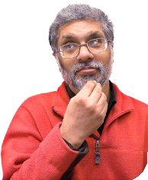
These are important words in the booklet.

This word
means….

Sometimes if a bold word is hard to understand, we will explain what it means.



Blue and underlined words show links to websites and email addresses. You can click on these links on a computer.

links

What is in this booklet
About this booklet 4
Looking at pharmacy services 5
About Central Bedfordshire 7
Pharmacies in Central Bedfordshire 10
Pharmacy services in Central Bedfordshire 12
What people told us 15
Ways pharmacy services can be better 18

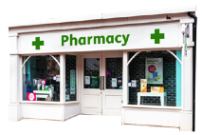

About this booklet

Central Bedfordshire Council is looking at pharmacy services in Central Bedfordshire.

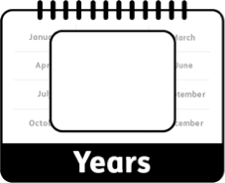
We have to look at pharmacy services every 3 years.
3

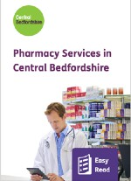
This booklet will tell you what we found out about pharmacy services in Central Bedfordshire, and how they could be better.

Looking at pharmacy services


When we look at pharmacy services we write a report called a Pharmaceutical Needs Assessment (PNA).


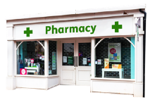
The PNA looks at:
Now

- What pharmacy services we have now.

- What pharmacy services we might need in the future.

Future

We use the PNA to help decide if we can:

New

- Let new pharmacies open.

Change

- Let pharmacies change how they work.


We will use what people tell us about pharmacy services in Central Bedfordshire when we write our PNA.


About Central Bedfordshire

Around 315,000 people live in Central Bedfordshire.


By 2028, we think that about 15,000 more people will live in Central Bedfordshire.

More

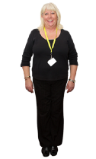


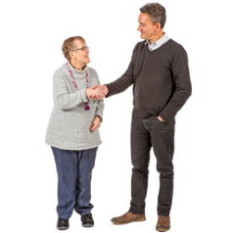
9 out of 10 people who live in Central Bedfordshire are white, either British or Irish.


We expect men in Central Bedfordshire to live to about age 80 and women to about age 84.


We expect men and women in Central Bedfordshire to stay healthy until they are about age 64.


The health of most people in Central Bedfordshire is about the same as the whole of England.


But this is not the same for everyone.


People in Central Bedfordshire are more likely than people in the rest of England to:

- Be overweight or obese. Obese means very overweight.

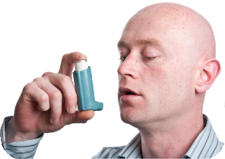
- Have asthma.

People in Central Bedfordshire are much more likely than people in the rest of England to:


- Get pregnant when they are younger than 18.

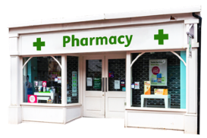
Pharmacies in Central Bedfordshire

38
There are 38 pharmacies in Central Bedfordshire.


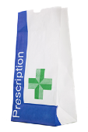
10 doctor's surgeries in Central Bedfordshire have a pharmacy.

10

Central Bedfordshire has nearly 13 pharmacies for every 100,000 people.

13 per 100,000

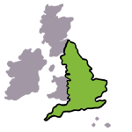
This is not as many as the rest of England.

Less

Some parts of Central Bedfordshire have more pharmacies than others.
Central Bedford- shire
More


6 in 10 people could walk to a pharmacy in less than 15 minutes.
15 minutes


Most people could drive to a pharmacy in less than 5 minutes.
5 minutes


31 pharmacies in Central Bedfordshire are open on Saturdays and 8 are open on Sundays.


We found out that there are lots of different pharmacy services in Central Bedfordshire which meet people's health needs.

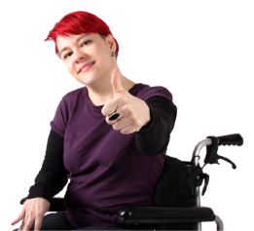
People are able to get to and use these services.

Pharmacy services in Central Bedfordshire
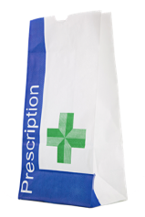
There are lots of services you can get at pharmacies in Central Bedfordshire, like:
•
Giving you medicines your doctor

prescribes.
Prescribe means to give you a note for medicines you need.


- Recommending and selling you other medicines.

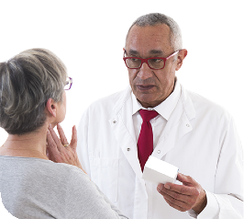

- Giving you advice about staying healthy.

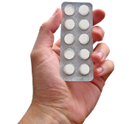

- Safely throwing away your old or unwanted medicines.

Pharmacies in Central Bedfordshire can also:


- Help you go to the right health services.


- Help you with common illnesses that are not serious.

Some pharmacies also provide:

- Extra help for people who have long-term conditions.

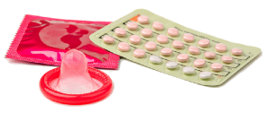
Help with emergency
•

contraception.
Contraception is medicine to stop pregnancy.


Some pharmacies also provide:

- Help with stopping smoking.

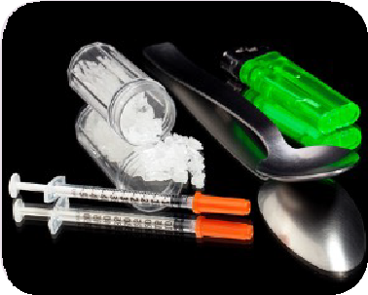
- Help for people who are addicted to drugs.


- Help for people who drink too much alcohol.

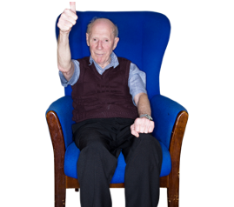
- Help making people feel comfortable at the end of their lives.

What people told us
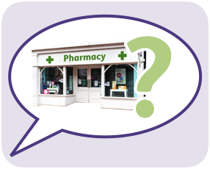
We asked people questions about pharmacies in Central Bedfordshire to find out what they think of them.


3,208 people answered these questions.

3,208 people


Most people have a pharmacy they prefer to go to.

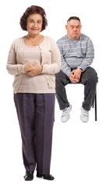
Most people visit the pharmacy for themselves, but a lot also visit pharmacies for family members.

Most people use their pharmacy to collect prescribed medicines.
Prescribed medicines are medicines a doctor has given you a note for.

People also use their pharmacy to:
- Buy other medicines. Some of these are recommended by a pharmacist
or pharmacy staff.

- Get advice about staying healthy.

- Throw away their old or unwanted medicines safely.


- in 2 people travel by car to their pharmacy.

1 in 2


- in 5 people walk to their pharmacy.

2 in 5

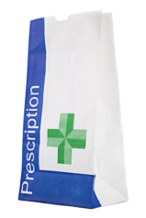
Most people use their pharmacy between 9am and 5pm on Monday to Friday.

9am to 5pm Monday to Friday


About 1 in 4 people use their pharmacy on a Saturday morning.

Saturday morning
1 in 4

Sunday
Less

Not as many people use their pharmacy on Sundays.

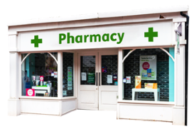

Ways pharmacy services can be better
Generally, pharmacies in Central Bedfordshire meet the needs of the people in Central Bedfordshire.

We will carry on looking at:

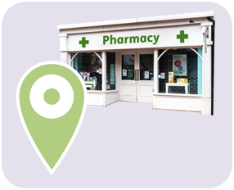
- Where pharmacies are.

- When pharmacies are open.


- What services pharmacies provide.

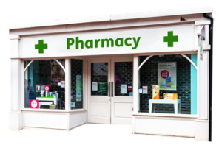
We will try to encourage all pharmacies to provide all the services.


We think more work should be done to see if enough pharmacies are open in Ivel Valley on Saturday evenings and Sundays.

Ivel Valley


We will look at ways to help pharmacies make it easier for people who do not speak English to use pharmacy services.

This Easy Read booklet was produced by easy-read-online.co.uk
The booklet includes images licensed from Photosymbols & Shutterstock.

